SpendWise: A Simple Backend Learning Project
Ideation Phase
Define the Problem Statements
Date: 7 February 2026
Team ID: SWTID-2026-9031
Project Name:SpendWise
Maximum Mark:2 Marks

Project Name: SpendWise
SpendWise is a simple backend learning project designed for students who want to understand the fundamentals of Node.js, Express.js, MongoDB, and JWT authentication. Many beginners struggle with complex tutorials and large-scale projects that introduce too many features at once. SpendWise focuses on core backend concepts like CRUD operations, authentication, and API structure, helping learners clearly understand how these technologies work together.

Customer Problem Statement Overview
A customer problem statement helps identify the difficulties faced by learners so that the project solution can directly address those challenges. For SpendWise, the “customer” is mainly students and beginner developers who are trying to learn backend development in a practical way.

Backend Technologies Used
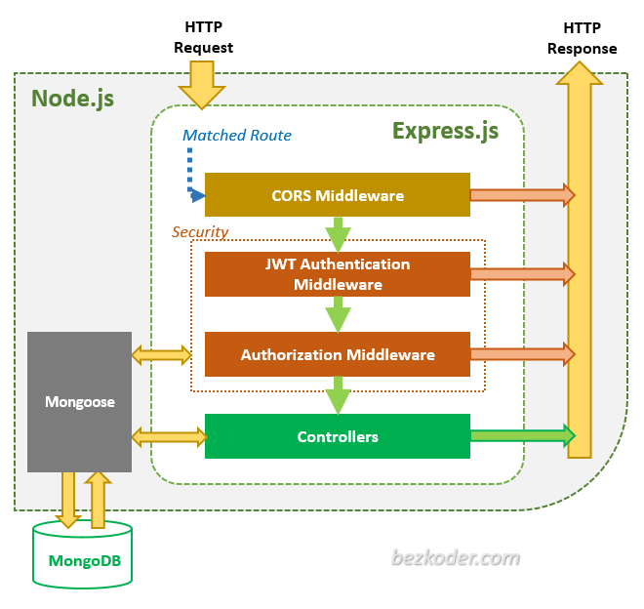
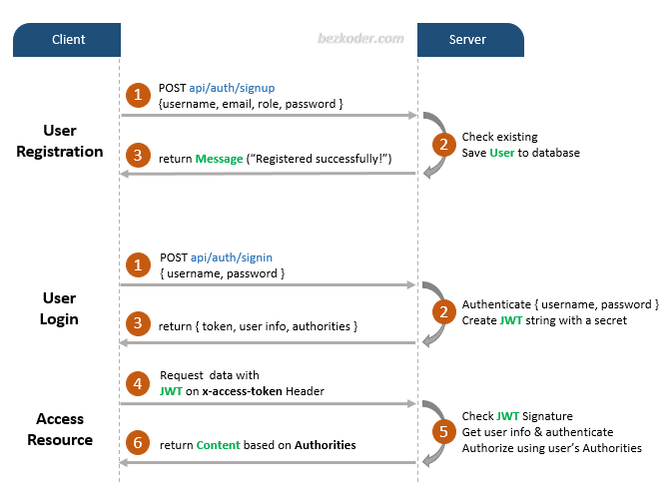
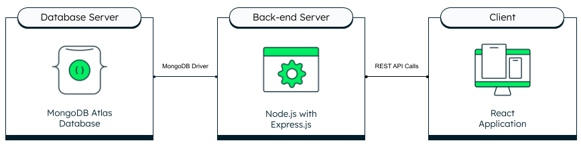
4
These technologies form the basic backend development stack used in SpendWise:
- Node.js – Runs JavaScript on the server side.
- Express.js – Framework used to build APIs easily.
- MongoDB – NoSQL database used to store user and expense data.
- JWT (JSON Web Token) – Used for secure user authentication.
Together, they help students understand API creation, database interaction, and secure login systems.

Customer Problem Statements
Problem Statement | I am (Customer) | I’m trying to | But | Because | Which makes me feel
PS-1 | A beginner learning backend development | Understand how backend APIs work with databases | Most tutorials focus on theory instead of practical examples | The project examples are often incomplete or too complicated | Confused about how backend components connect
PS-2 | A student working on a backend mini-project | Create a working API with authentication | Many resources mix frontend and backend together | I only want to focus on backend logic first | Overwhelmed and unsure where to start
PS-3 | A self-learning developer | Implement secure login and protected routes | I struggle with token generation and verification | Documentation explains concepts but not the complete flow | Frustrated when authentication fails
PS-4 | A student preparing for technical interviews | Demonstrate CRUD operations with a real backend example | Most examples online are either too simple or production-level | They skip beginner-friendly explanations | Underconfident during project discussions

Example CRUD Workflow in SpendWise
